WOW! / Right configuration with iQ.
Calibrate driver assistance systems quickly and profitably
Künzelsau – August 2019 – Driver assistance systems support the driver in certain driving situations. The focus is on safety aspects, increasing driving comfort and improving economic efficiency. To ensure correct and safe functioning, these systems have to be checked and calibrated regularly. The calibration system ACS cars by WOW! Würth Online World (WOW!) offers a flexible system for the calibration of all relevant vehicle brands.
WOW! offers an easy-to-use and flexible tool for the calibration of driver assistance systems with ACS cars, which can be used as an extension of the WOW! multibrand diagnosis. The calibration system contains the complete package of hardware and software applications as well as the logical connection of them. The information for the calibration is integrated into the diagnostic system, so that the complete calibration process can be performed with one system. While the static calibration is carried out with the help of the calibration board carrier, the dynamic calibration can be performed via the WOW! diagnostic software.
Thanks to the well thought-out system and fast alignment of the vehicle with moving parts, the calibration system saves time and money for the workshop. Because of this, ACS cars is especially suited for independent -workshops, windscreen services, chassis workshops and tire dealers.
Designed for easy handling WOW! ACS cars enables the user the one-man operation instead of group work. Thanks to a wheeled calibration board carrier that can be adjusted using levers, the movable calibration board holder with secure spring mechanism for the camera calibration and the quickly adjustable crossbeam for radar calibration. With a bit of practice, a mechanic can calibrate driver assistance systems in about 10 to 15 minutes, instead of the usual 20+ minutes. This will also be supported by the common approach for different manufactures. The user will get to know the system quickly this way. Error rates and set-up times will be reduced.
From small cars to vans, ACS cars offers maximum flexibility. The connection to the multi-brand diagnostic system iQ by WOW! ensures that the system remains state-of-the-art with the latest software updates. It also can be extended at any time thanks to the flexible use of the double-sided printed calibration boards. The market coverage is continuously being expanded. While the camera calibration is already available, the complete solution with the coming equipment for the radar calibration will be available within 2019. This way, workshops will have the latest information on vehicles, models and systems.
From the hardware equipment to the software and the training, the user receives everything from one source with ACS cars by WOW! Würth Online World.

You can find more information on www.wow-portal.com/acs_cars_en
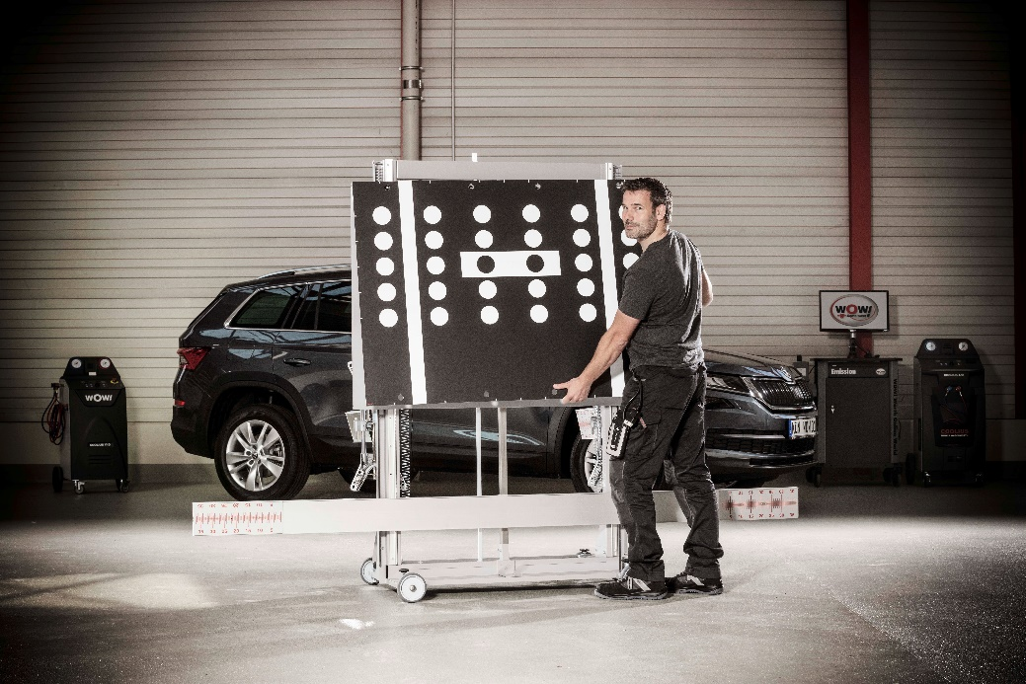
Complicated calibrating is now thanks to WOW! ACS cars a thing of the past.
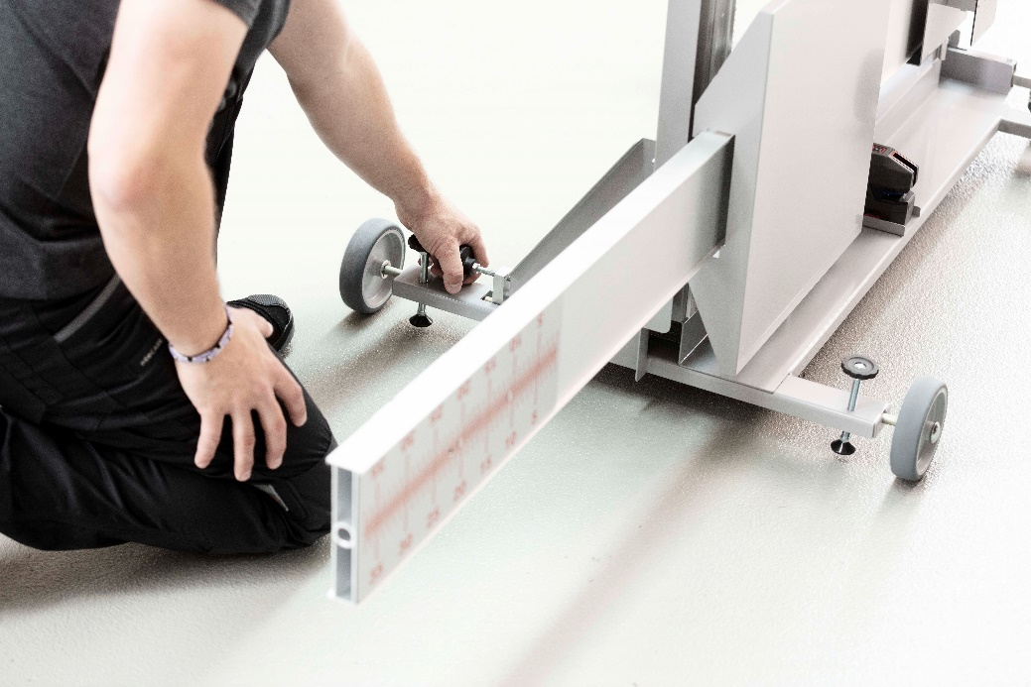
Easy and fast alignment with moving parts and a well thought-out design.

About WOW! Würth Online World
Workshops and car dealerships with the latest developments and solutions for diagnosis, exhaust emission testing and air conditioning service from WOW! are technically well prepared for the future. In addition to service companies and car dealerships, also suppliers and vehicle manufacturers from 35 countries are customers of the Würth GROUP company, which was founded in 2000. Worldwide, 50,000 customers rely on diagnostic solutions from WOW!. Further information can be found on the internet at www.wow-portal.com.
Contact
WOW! Würth Online World GmbH
Sibylle Kaufmann
Schliffenstraße 22
D-74653 Künzelsau
Phone +49 (0) 79 40 / 9 81 88 10 55
Fax +49 (0) 79 40 / 9 81 88 10 99
sibylle.kaufmann@wow-portal.com
www.wow-portal.com

