WOW! / Automechanika 2018 in Frankfurt: Hall 09, Stand D06
Tackle the workshop challenges
Künzelsau – 13. August 2018 – A workshop must have a wide variety of tasks and processes in its daily work routine. That's why it's important to have a partner you can rely on. The specialist for diagnostic technology and system solutions WOW! Würth Online World GmbH presents its comprehensive multi-brand vehicle diagnosis at this year's Automechanika in Frankfurt and focuses on products and service solutions for the workshop. The company will also exhibit its highlights from the areas of air conditioning service and exhaust emission test on two stands.
WOW! Würth Online World (WOW!) has been developing intelligent hardware and software systems for the dynamic vehicle industry since 2000. In Hall 09, Stand D06 and at the Würth booth in Hall 11.0, C35, visitors to Frankfurt will be able to experience the diverse concepts and solutions of the Würth subsidiary. Because for the company WOW!, one thing is clear. Service makes the difference. From installation to training and repair, to maintenance via the hotline and beyond, WOW! Service offers comprehensive solutions and is a strong partner to the workshop.
Four eyes repair more than two
The aim of the company is the continuous (further) development of customer-oriented and future-oriented solutions for the automotive engineering industry. In the field of vehicle diagnostics, WOW! provides the diagnostics specialist at the trade fair, in addition to proven functions such as the power search, the flightrecorder or the link to the technical data, first insights into the topics currently being developed in the areas of calibration of driver assistance systems, advanced troubleshooting and augmented reality.
WOW! Würth Online World turns augmented reality into a concrete workshop benefit. WOW! is the first company bringing external workshop technicians by request to the screen ... to the garage ... to the car. Live and solution-oriented. At the fair, the company is showing the new system, which represents an innovative remote help that is web-based and can be used with any end device. WOW! also presents the new concept for the calibration of driver assistance systems in Frankfurt. In the upcoming software updates, the diagnostic system will be extended with the calibration steps specified by the manufacturer, so that the customer can perform the complete calibration procedure in connection with the new tool.
WOW!'s advanced troubleshooting software is the first online data compass for the workshop, and presents an additional extension of the existing software and hardware support available for any service and repair application. WOW! thus supports the car workshops and, in concrete terms, the mechanics even better. The new, integrated troubleshooting synchronizes the technical information from various data sources with the WOW! repair database. This eliminates time-consuming search processes for the workshop employees.
Air conditioning service from the manufacturer - Emission according to guideline 5 Rev.01
In addition to vehicle diagnostics, WOW! also presents air conditioning service units, which are developed and manufactured in-house and undergo a unique quality check. High-quality components ensure optimum performance. With the air conditioning service unit COOLIUS Y50A WOW! offers a flagship for the air conditioning service. The system provides the air conditioning service with integrated refrigerant analysis. The composition of the existing refrigerant is evaluated and documented in detail on a printout. In addition to the documentation, this also creates new opportunities for dealing with contaminated refrigerant.
According to the latest guideline 5 Revision 01 also the exhaust emission test devices of the WOW! Emission series are working, which the company is exhibiting at the fair in Frankfurt. The systems offer a flexible and mobile application for exhaust emission testing with legally compliant, high-performance software in order to be able to test all vehicles including EURO 6 / VI from 2019 onwards.

You also want to tackle your workshop challenges? Then find out in advance at www.wow-portal.com.

Picture:

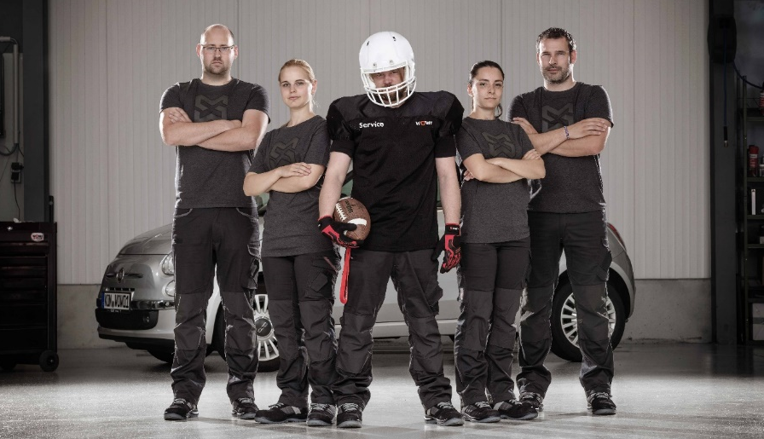
Underline:
Tackle your workshop challenges together with the WOW! service team. Hall 9.0, Stand D06.

About WOW! Würth Online World
Workshops and car dealerships with the latest developments and solutions for diagnosis, exhaust emission testing and air conditioning service from WOW! are well prepared for the future. In addition, the company offers personal advice and comprehensive service from one source. Besides service companies and car dealerships also suppliers and vehicle manufacturers from 35 countries are customers of the Würth Group company, which was founded in 2000. Worldwide, 50,000 customers rely on diagnostic solutions from WOW!. Further information can be found on the Internet at www.wow-portal.com.

Contact
WOW! Würth Online World GmbH
Sibylle Kaufmann
Schliffenstraße 22
74653 Künzelsau
Tel: +49 (0) 79 40 / 9 81 88 10 55
Fax:+49 (0) 79 40 / 9 81 88 10 99
sibylle.kaufmann@wow-portal.com
www.wow-portal.com

